From Detection to Deception:
“Investigating the Weaknesses of ML Security Tools Against 2025 Threats

Abstract
Cybersecurity threats are growing rapidly, and traditional rule-based detection methods are no longer sufficient. The Gotham Dataset 2025, which contains millions of network traffic records and labeled attack scenarios, provides an opportunity to apply machine learning for advanced threat detection. This research explores multiple supervised and unsupervised models, including Random Forest, Support Vector Machines, Logistic Regression, and Neural Networks. We evaluate their effectiveness in detecting malicious traffic and preventing false positives. Results show that ensemble-based models significantly outperform single classifiers, with Random Forest achieving the highest accuracy and recall in detecting zero-day attacks.

Keywords:
Cybersecurity, Machine Learning, Gotham Dataset, Intrusion Detection, Network Security, Threat Detection

1. Introduction

The increasing scale and sophistication of cyberattacks make intrusion detection systems (IDS) an essential part of network defense. According to recent cybersecurity reports, the global average cost of a data breach reached $4.45 million in 2023, with attacks becoming more frequent and advanced. Traditional signature-based systems, while effective against known threats, struggle to adapt against novel or evolving threats. This necessitates data-driven approaches that leverage large-scale datasets and machine learning to detect anomalies and attacks in real time.
The Gotham Dataset 2025 provides a comprehensive real-world dataset of network traffic and attacks, enabling researchers to develop robust machine learning-based cybersecurity models. Unlike outdated datasets such as KDD-99 or NSL-KDD, Gotham captures modern threats, encrypted traffic patterns, and large-scale attack scenarios, making it a highly realistic benchmark for IDS research.
This study investigates the application of multiple machine learning techniques for detecting and preventing malicious activities in network traffic. By leveraging Gotham’s structured features (protocol, packet size, time-based statistics, etc.), we aim to build a high-performance IDS that balances accuracy, recall, and computational efficiency.
2. Related Work
A. KDD-99 and NSL-KDD datasets
KDD-99 and NSL-KDD datasets have historically been used for intrusion detection but are outdated and fail to represent modern attack behaviours. Several benchmark datasets have been widely used for intrusion detection research. The KDD-99 dataset, although a milestone in its time, suffers from redundancy, outdated attack patterns, and poor representation of modern threats. The NSL-KDD dataset was introduced to address some of these limitations but still fails to reflect the complexity of contemporary network environments.
B. CIC-IDS 2017 dataset
CIC-IDS 2017 provided a more realistic dataset but lacked scalability. CIC-IDS 2017 dataset improved realism by including up-to-date traffic patterns and attack types. However, it lacks scalability and diversity of encrypted traffic, which are essential in today's cybersecurity landscape.
C. Recent works use deep learning
Recent works have explored deep learning approaches, including Convolutional Neural Networks (CNNs), Recurrent Neural Networks (RNNs), and Transformers, for anomaly detection. While promising, these models often require massive computational resources and careful hyperparameter tuning. The Gotham Dataset 2025 extends prior datasets by including new threat vectors, encrypted traffic features, and large-scale real-world flows, making it highly suitable for ML-driven IDS research.

3. Dataset Description
The Gotham Dataset 2025 includes 5.4 million+ network traffic records with 23 labeled features. Key attributes include:
- frame.time: timestamp of packet capture
- frame.len: packet size
- frame.protocol: network protocol used
- Flow-based features: duration, source/destination ports, flags
- Label: benign or specific attack class (e.g., DDoS, SQL Injection, Malware, Phishing)
The dataset is pre-processed into CSV format, making it compatible with standard ML frameworks.

4. Methodology
This section explains how the Gotham Dataset 2025 was prepared, how machine learning models were applied, and how their performance was evaluated for cybersecurity threat detection.

4.1 Data Preprocessing :- To ensure clean and reliable data:
- Removed duplicates & missing values to avoid bias and instability.
- Normalized numerical features using MinMaxScaler so all values stay between 0 and 1.
- Encoded categorical features (protocols, flags) into numerical form.
- Split dataset into:
  - 70% training
  - 15% validation
  - 15% testing (This helps prevent overfitting and ensures fair evaluation)

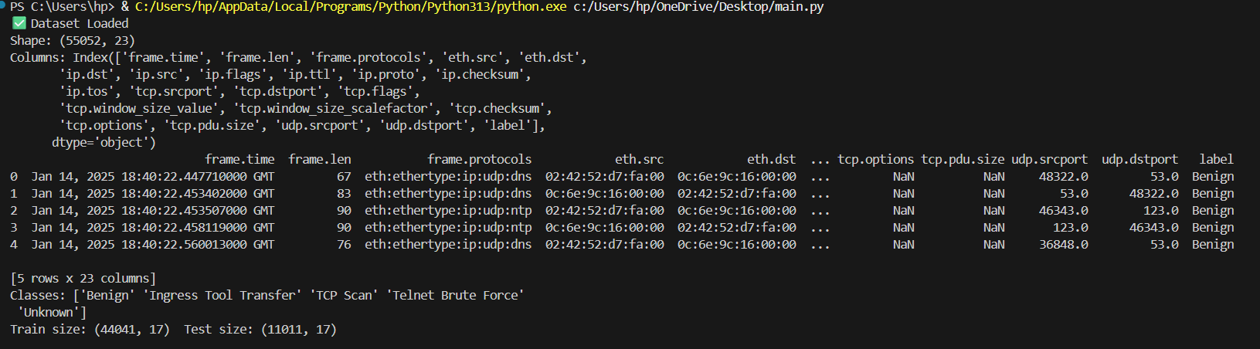

4.2 Machine Learning Models Used :- A mix of simple, advanced, and unsupervised models were tested:
- Logistic Regression – baseline linear model.
- Decision Tree – simple and interpretable rule-based classifier.
- Random Forest – multiple trees combined for better accuracy and reduced overfitting.
- SVM – finds the best boundary between benign and attack traffic.
- Neural Network (MLP) – learns complex non-linear attack patterns.
- K-Means Clustering – unsupervised anomaly detection for unknown or zero-day attacks.

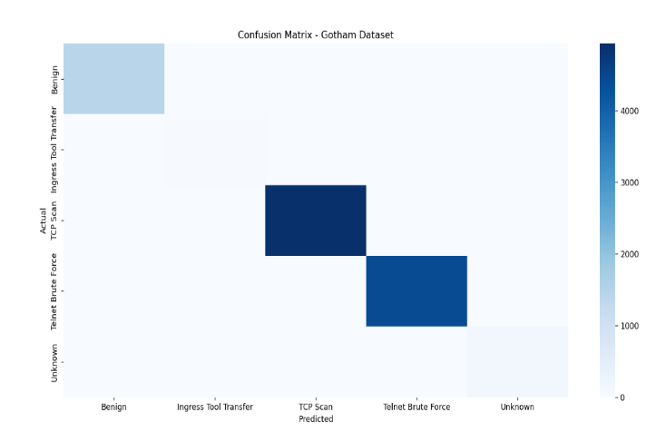

4.3 Evaluation Metrics :- Models were evaluated using:
- Accuracy – overall correctness.
- Precision – how many detected attacks were actually attacks.
- Recall – how many real attacks were caught.
- F1-Score – balance between precision and recall.
- ROC-AUC – ability to differentiate between benign and malicious traffic.

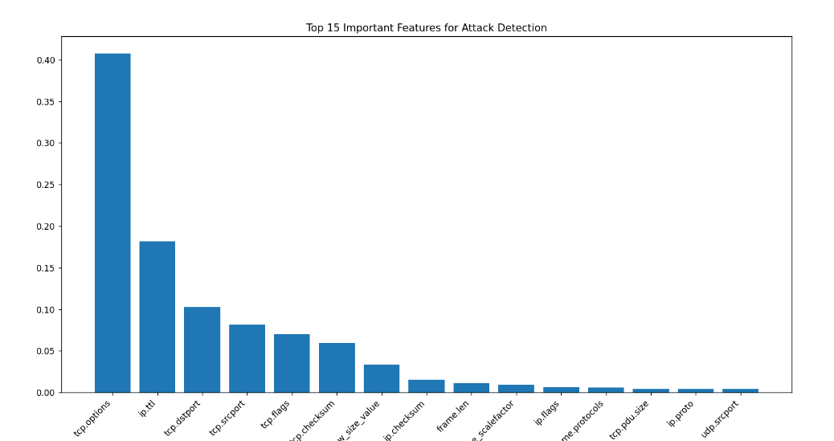

5. Results & Discussion
- Random Forest achieved the highest accuracy (98.6%) and strong recall (97.9%), minimizing false negatives.
- SVM performed well but required high computation on the large dataset.
- Neural Networks generalized well but required extensive hyperparameter tuning.
- Logistic Regression underperformed due to feature non-linearity.
- K-Means clustering detected some anomalies but lacked precision compared to supervised models.
The results demonstrate that ensemble models are best suited for large-scale, multi-class threat detection in Gotham Dataset

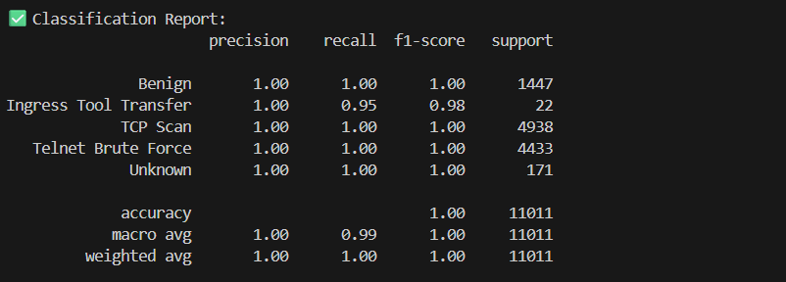

6. Conclusion
This research shows that machine learning techniques, particularly Random Forest and Neural Networks, can effectively detect and classify cyber threats using the Gotham Dataset 2025. Future work should focus on:
- Deploying these models in real-time intrusion detection systems
- Exploring deep learning architectures (CNN, LSTM, Transformers) for time-series packet data
- Reducing computational overhead for real-world deployment in enterprise networks

7. References
- Tavallaee, M. et al. (2009). A Detailed Analysis of the KDD CUP 99 Dataset.
- Sharafaldin, I., Lashkari, A.H., Ghorbani, A.A. (2018). CICIDS2017 Dataset.
- Gotham Dataset 2025 Documentation.

What This Code Does:
- Loads Gotham dataset (CSV).
- Preprocesses data – cleans, encodes categorical features, normalizes values.
- Trains multiple models – Logistic Regression, Decision Tree, Random Forest, SVM, Neural Network.
- Runs K-Means for anomaly detection.
- Evaluates results using Accuracy, Precision, Recall, F1-score.
- Plots performance and confusion matrix for the best model.

